Project Report

Development of a Legal Chatbot for Bangladesh using Retrieval-Augmented Generation (RAG)
Group: 6
Course: CSE299
Section: 21
Supervisor: Mirza Mohammad Lutfe Elahi
Semester: Spring 2025
Date: April 22, 2025
Name | ID
Karma Sonam Rabgay | 2233716032
Md. Fazle Kabir Tihum | 2131035642
Irfan Ahamad Sochho | 2012637642
Saad Bin Hasan | 2011670642
Team Members:

Introduction

Navigating legal information can be quite challenging, as it is often complex and difficult for the average person to comprehend. Consequently, there is a rising demand for intelligent systems that can bridge the gap between legal documentation and public understanding. This project seeks to develop a legal chatbot capable of answering inquiries related to Bangladeshi law. Utilizing a Retrieval-Augmented Generation approach, we will merge information retrieval with advanced language models to improve the relevance of the responses given.

Objectives
- To develop a chatbot that can understand and respond to questions about the Bangladesh Law using RAG architecture.
- To ensure that the system is lightweight and easy to use.
- To provide a user-friendly interface for interaction.

Overview
This project presents a legal chatbot built using a Retrieval-Augmented Generation (RAG) approach to answer queries based on the Bangladesh Law. It combines a retriever—using FAISS and sentence-transformers—to fetch relevant legal context, and a generator—powered by the Mistral 7B model—to produce relevant responses.
These following components were used:
- Document Loader: Using PyMuPDFLoader to load a document.
- Text Splitter: RecursiveCharacterTextSplitter to split the document into smaller text chunks.
- Embedding Model: All-MiniLM-L6-v2 for embeddings of the text chunks.
- Vector Database: Required to store the embeddings using FAISS.
- Query: Question provided by the user.
- Retrieval: Retrieves the “k” most similar text chunks based on the user query.
- LLM: Generates final response based on the retrieved text chunks.

The following diagram illustrates how the RAG (Retrieval-Augmented Generation) system works:
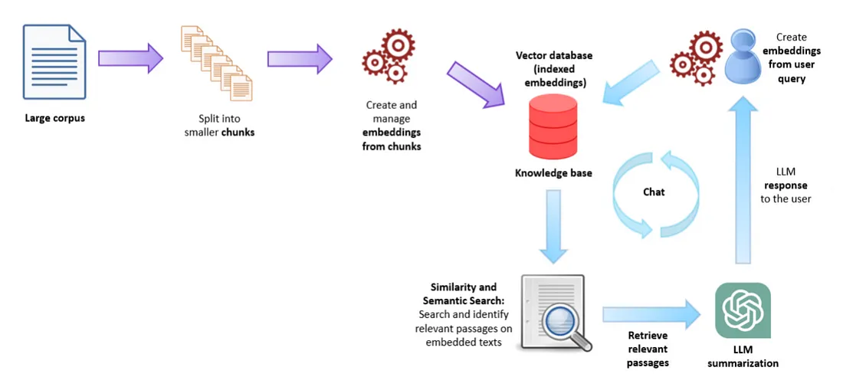
Figure 1: RAG-based Chatbot

Methodology
Initially, the chatbot was attempted to run locally in the VS Code platform, but due to hardware limitations while loading the large language model (Mistral 7B), the development was moved to Google Colab, which offered better GPU support.
The following Python libraries and frameworks were used:
- LangChain – for document chunking, embedding, and managing the RAG pipeline.
- PyMuPDFLoader – to parse legal documents in PDF format.
- FAISS – for vector storage
- Transformers – for loading and interacting with the Mistral 7B model.
- Accelerate – for optimized inference with hardware acceleration.
- Sentence-Transformers – for generating a semantic embedding of legal text.
- Gradio – for Frontend.
- Bitsandbytes - is used specifically for quantizing the model to 4-bit precision, reducing memory usage and enabling efficient loading and inference
- Torch – provides the core functionalities for working with tensors, models, and GPU acceleration.
Moreover, Google Colab & Google Drive were used for executing notebook and storing models.

Implementation
This legal chatbot follows RAG architecture, which is divided into two major sections:
- Indexing
- Loading: This involves importing all the documents or information to be utilized.
# Loading the pdf
all_documents = []

for pdf_path in pdf_paths:
loader = PyMuPDFLoader(pdf_path)
documents = loader.load()
print(f"✅ PDF loaded from {pdf_path} with {len(documents)} pages.")
all_documents.extend(documents)

- Splitting: Large documents are divided into smaller pieces, for instance, sections of no more than 500 characters each.
# Splitting into manageable chunks
splitter = RecursiveCharacterTextSplitter(chunk_size=500, chunk_overlap=20)
docs = splitter.split_documents(all_documents)
print(f"✅ Splitting complete. Total chunks: {len(docs)}")
- Embedding: The data is converted into vector form using an embedding model from Huggingface.
# Initialize embedding model
embedding_model = HuggingFaceEmbeddings(model_name="sentence-transformers/all-MiniLM-L6-v2")

# Create embeddings and store in memory
vector_db = FAISS.from_documents(docs, embedding=embedding_model)
print("✅ Vector store created in memory.")

- Storing: These vector embeddings are saved in a vector database.

- Retrieval & Generation
Prior to integrating Mistral 7B into our system as our main LLM model, we experimented with lightweight language models such as TinyLlama and GPT-2.

GPT-2:
model_name = "gpt2-medium"
TinyLlama:
model_name = "TinyLlama/TinyLlama-1.1B-Chat-v1.0"

- Integration of a heavier model from Huggingface i.e. Mistral 7B.
# Load or download Mistral 7B model
model_name = "mistralai/Mistral-7B-Instruct-v0.1"

- To enable natural language generation in the chatbot, the Hugging Face pipeline API was used to create a text-generation pipeline. This retriever fetches the top 5 relevant document chunks, which are then passed into the language model for legal responses.
my_pipeline = pipeline(
"text-generation",
model=model,
tokenizer=tokenizer,
max_new_tokens=1000,
do_sample=True,
torch_dtype=torch.bfloat16,
device_map="auto",
)

# Set up Retriever
retriever = vector_db.as_retriever(search_kwargs={"k": 5}
- A get_answer () function was created to handle user queries. It first retrieves the top relevant document chunks using the retriever.
def get_answer(query):
try:
retrieved_docs = retriever.invoke(query)
context = " ".join([doc.page_content for doc in retrieved_docs])

# 1. Handling Empty Context
if not context:
return "No relevant information found in the document."

# 2. Refining Prompt Structure
prompt = f"""### Instruction: You are a legal expert specializing in Bangladesh Law.
Answer the question based on the context.
### Context: {context}
### Question: {query}
### Answer:"""

# Generate response using pipeline
response = my_pipeline(prompt)

# 3. Extracting and cleaning the answer
answer = response[0]['generated_text'].split("### Answer:")[-1].strip()
answer = re.sub('\s+', ' ', answer)

return answer

except Exception as e:
return f"An unexpected error occurred: {e}"

Tests and Results
# Example Query1
user_query = "What is the labour act of Bangladesh about?"
answer = get_answer(user_query)
print(answer)

Result: The Bangladesh Labour Act, 2006 consolidates and amends the laws relating to employment of workers, relations between workers and employers, determination of minimum rates of wages, payment of wages, compensation for injuries to workers during working hours, formation of trade unions, raising and settlement of industrial disputes, health, safety, welfare and working conditions in Bangladesh. The Act also provides for the establishment of Labour Courts and their powers. The Act aims to regulate and protect the rights of workers in Bangladesh.
# Example Query2
user_query = "What is the punishment for murder in Bangladesh?"
answer = get_answer(user_query)
print(answer)

Result: If a person is found guilty of murder in Bangladesh, they can be punished with the highest punishment prescribed for other offences by Bangladeshi laws. In addition, they may face imprisonment of the description provided for the offence, or with fine, or both.
# Example Query3
user_query = "Is abortion legal in Bangladesh?"
answer = get_answer(user_query)
print(answer)

Result: Bangladesh Labour Act, 2006 prohibits employers from engaging women in work and women from working during maternity leave. There is no specific provision in Bangladesh law that prohibits the legal practice of abortion in Bangladesh. The Constitution of the People’s Republic of Bangladesh also does not explicitly prohibit abortion.

User Interface with Gradio
# Initialize an empty list to store chat history
chat_history = []

def gradio_interface(query):
global chat_history
answer = get_answer(query)
chat_history.append([query, "User"])
chat_history.append([answer, "Legal assistant"])
return chat_history

# Define the Gradio interface layout
iface = gr.Interface(
fn=gradio_interface,
inputs="text",
outputs="chatbot",
title="Legal Q&A System",
description="Ask questions about the Bangladesh Law, and the system will generate answers based on the text of the Bangladesh Law.",
theme="default"
)

# Launch the interface
if __name__ == "__main__":
iface.launch(share=True)

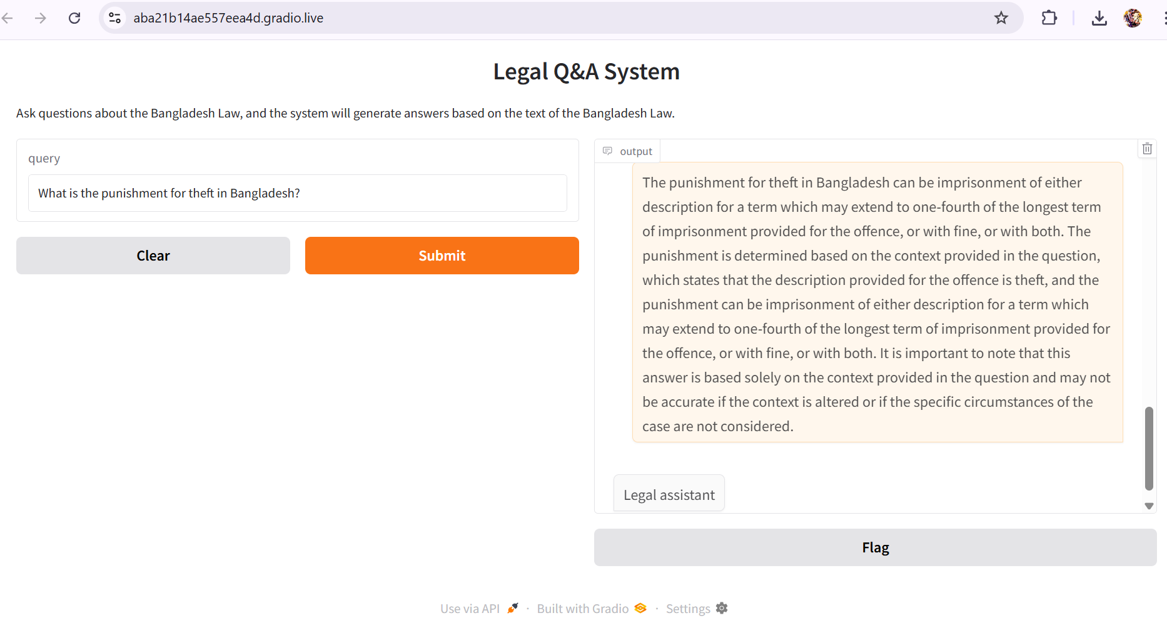
Figure 2: Frontend Implementation using Gradio interface

Conclusion
This project presents how AI can enhance access to legal information through a chatbot that uses Retrieval-Augmented Generation (RAG). By integrating document retrieval with a language model, the system interprets user questions and offers accurate answers based on Bangladesh Law. In today's digital age, large language models have great potential in fields like law, education, and public services, helping to simplify complex challenges and making information easier to find. As AI evolves, its impact on these sectors is set to increase, making such innovations essential. Tools like this will play a key role in how we learn, work, and solve problems in the future.

References
Hugging Face. (n.d.). Mistral-7B-Instruct-v0.1 [Model]. Hugging Face.
https://huggingface.co/mistralai/Mistral-7B-Instruct-v0.1
Hugging Face. (n.d.). all-MiniLM-L6-v2 [Model]. Hugging Face.
https://huggingface.co/sentence-transformers/all-MiniLM-L6-v2
Julija. (2023, July 30). What is Retrieval Augmented Generation (RAG)? Medium.
https://medium.com/@drjulija/what-is-retrieval-augmented-generation-rag-938e4f6e03d1
Ministry of Law, Justice and Parliamentary Affairs. (n.d.). Bangladesh Laws [PDF files].
bdlaws.minlaw.gov.bd. http://bdlaws.minlaw.gov.bd/

Vashist, V. (2023, July 17). Chatbot using RAG (Retrieval Augmented Generation).
Medium. https://medium.com/@vidiptvashist/chatbot-using-rag-retrieval-augmented-generation-3ee577de4186

